Planning App

# Goal of the final app

The purpose of this mock planning application is to introduce the concept of a particular shopping app. Primarily this app, Geo – shopping, which combines a typical shopping list app with the ability to get notifications when near a shop that was marked earlier via the combination of GPS location and Geofences.

The main goals of the app are the following:

* Creation of items for a shopping list
* Able to mark/pin shops using google maps and save their location
* Using Geolocation to get the apps position
* Send a notification reminder when app reaches marked shop location via Geofences
* Mark off items from the shopping list as they are bought

The overall goal of the app is to reduce the need to remind oneself to find your shopping list when you get to the shops. This app conveniently combines this all into one app, making it very convenient for the user.

# Stories about potential users of the final app

User

For this user they are a mother who must provide food for her family. She constantly forgets her shopping list behind, either at home or in the car. This constantly frustrates her as she never remembers the full shopping list. I will list below some tasks that she may perform when using this app.

Task 1

In this task the user will create a shopping list:

* Tap the add item below which will bring up the add item screen
* The user will type the name and amount of the item they wish to add to their shopping list.
* App will bring them back to the home screen.
* This previous three steps will be repeated until the shopping list is done.
* Close the app.

Task 2

Add shop to notification:

* Tap the menu button to bring up the menu and select the shop button.
* The user will be presented with a Google Maps screen where they can enter their desired shop.
* Once the user has selected their desired shop, a confirmation dialog will show confirming on their selection.
* Get returned to the main screen.
* Close the app.

Task 3

Get notification:

* With the phones GPS on, the user should get a notification popup when they get close to their selected shop.
* User will click the notification and be brought straight into the app with their list open.
* User can proceed to tick off items as they buy.
* Close app when done.

# Comparison with existing apps

Below is an existing app that is very similar to my app GeoShopping. I’ll be comparing them to GeoShopping by listing their advantages and disadvantages over it.

Listonic

Listonic is a free smart grocery shopping list that is #1 free shopping list app in South Africa.

Advantages of Listonic

* Has a cloud based sync system that allows users to share lists with friends.
* Built for many types of devices (Phones, smart watches, tablets).
* Can send shopping list to someone who doesn’t have the app via an SMS
* Provides useful tips as you add items to your shopping list.
* Has voice recognition for adding items.
* Clean, sleek and simple UI design.

Below are two images showing off the tips feature and sharing feature of Listonic.

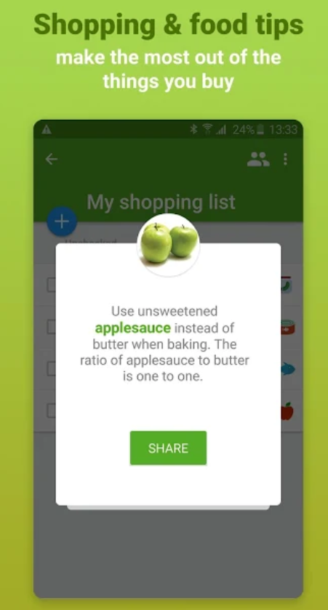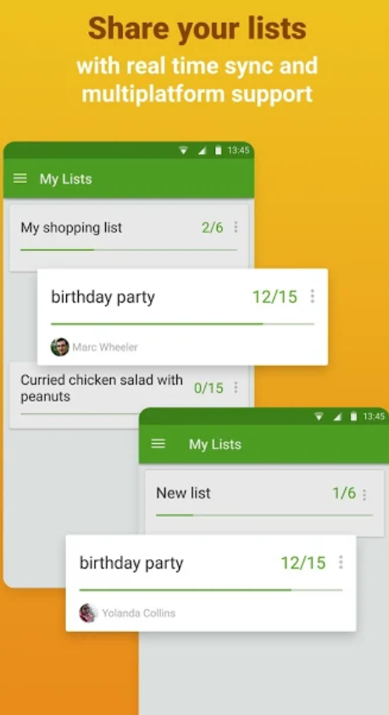

Disadvantages of Listonic

* The app can take a while to load up and check items. Making the user experience very frustrating, especially given its simple UI design.
* Syncing and sharing list can use up your phone’s mobile data.
* Has constant pervasive ads that can block most of the screen.
* If you have a bad mobile connection, the sharing and syncing of shopping list can fail.
* Doesn’t identify duplicate items when adding items. It just adds a new item instead of merging.

Advantages of GeoShopping

* Allows users to set up alert notifications for the shop they want to shop at.
* Search for shops via Google maps to set up the alert notification.
* Simplified UI design, which primarily focuses on creating shopping lists and finding shops to send a notification.
* Does not contain any ads.

Disadvantages of GeoShopping

* This app may be too simple for some users. Users may want a vast catalogue of grocery items, or categories to shop by.
* This app relies on that the phone’s GPS is working and accurate, as this could cause false notifications for some users if that is not the case.
* Google maps might not have some local shops or not be accurate about their position. This could lead to notifications being sent at wrong locations.
* Limited to only 1 shop notification at a time.

# List of technological challenges

I believe that these are the following technological challenges that I will face while developing the app.

## Keeping data persistent

The app needs to be able to store the users shopping list and the coordinates of the shops used for Geofencing. There are variety of technical means to solve this problem and this should be achieved either through the following; session variables, cookies or building a simple SQLite database. I believe that implementing one of these will allow the app to save its data.

## Google Maps

The app needs to invoke google maps in which the user can then search a shop that when selected, would be added to a list of shops needed to be notified. A Google map API key will need to be generated in order to use the Google maps API. These are very simple to obtain by using a google account and visiting the Google maps developer site and generating the key.

## Geofencing/Geolocation

The app needs to track the users current GPS location and use this information to determine when to trigger the notifications. Permissions to access the phones GPS will also be needed. This can be achieved by using the phones GPS to give the app the Gelocation of the app.

## Notification

Being able to push notifications to the user’s phone with the right information, when they reach their destination at the right time. This feature is essential to the app, especially its trigger, which is tied to the previous point.

## Complexity

This app may be incorporating too many technological features which could cause the app to be finished in a rushed and unfinished state. Strategical compromises may have to be made if certain technological features listed above are too hard or too time consuming to integrate into the app.